CMPE – 272: ENTERPRISE SORFTWARE PLATFORMS

PROJECT IDEA OVERVIEW

GROUP #26

**TITLE – “REAL TIME STOCK MARKET PREDICTION AND VISUALIZATION USING ADVANCED TOOLS AND TECHNOLOGIES.**”

**INTRODUCATION TO THE TOPIC –**

- A stock market is a public market where you can buy and sell shares from publicly listed companies. The stocks known as equity represent the ownership of the company. The stock exchange is like a mediator which allows buying and selling of the stocks.

- Stock market is an essential domain which benefits both the company to raise the capital and an individual to generate personal wealth. A stock market essentially represents the state of economy.

- Stock market prediction is an attempt made by the investor or the interested party to make forecast the value of an individual stock, a particular sector or the market as a whole.

- There are two most commonly used practices while predicting the value of a stock: Fundamental analysis and technical analysis. In fundamental analysis the price is predicted based on the company’s price/ earnings while in technical analysis patterns, past trends are studied. The fundamental analysis helps in getting the overall price of a stock while the technical analysis helps in getting the entry price of a stock.

- With more and more stocks, new companies being listed and historical data being generated there are ‘n’ number of tools and technologies being developed to accurately predict the stock price, the overall market trends and the future of the company. All these tools and technologies help the clients/stock holders make a sophisticated guess as and invest in the right stocks/segments of the company.

**ABSTRACT-**

- Stock market prediction helps the end user to predict the value of a stock based on the historical data, physical, psychological factors, rational and irrational behaviour. However, all these factors keep on changing drastically which make the stock price volatile and the entire process of predicting the value of a stock a tedious process.

- There are multiple approaches to predict the value of a stock – Using Machine Learning we can use the concept of Long-Term Short-Term Memory Network (LSTM) which work on time-series data and have a chain like structure. And the second part is to build a dashboard using Plotly is python for stock analysis.

- In our project we are would be using an open-source dataset like NSE Tata Global Dataset, which is a dataset of Tata Beverages from Tata Global Beverages Limited.

- On this dataset first data pre-processing would be performed using python to get the opening price, closing price and removing unnecessary values and outliers. Next, we would be using Kafka for pipelining logs from source to topics and training a model in parallel. Additionally, we would incorporate technologies like Nodejs for developing the entire server architecture and TensorFlow.js for real time prediction. Lastly for this project we would use a SQL or MongoDB database.

**APPROACH & TECHNOLOGIES USED -**

Our approach for the entire project would be as follows-

1.) The entire server-side architecture would be constructed using ML principle.

2.) TensorFlow.js would be used for making a ML model architecture

3.) Kafka would be used for real time data streaming and pipelining.

4.) The entire database would be stored using MongoDB or MySQL.

**ARCHITECTURE OVERVIEW**

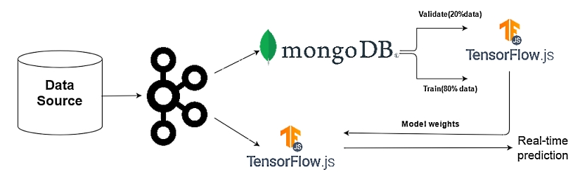

**PERSONAS**

Personas are fictional profiles which represent groups of similar people in a targe audience. In this project we would be considering three personas:

1. **Day Trader**

Profile: Mid aged(25-30years), Has recently started investing and has limited funds to invest.

Typical traits and Requirements: Wants to earn maximum from single trades, has short term goal plans. Looking for a platform which would notify him/her with quick updates regarding the nature of the stocks.

1. **Long Term Trader**

Profile: Seasoned investor, passive observer and takes decisions based on fundamental analysis price of stock. Has been regularly earning and investing in stocks.

Typical traits and Requirements: Believes in long holds, low-risk taker. Is looking for some platform which would suggest fundamentally strong stocks based on historical data and other pointers- sentiments of people, news etc.

1. **The Company** (Whose stocks have been registered for investing)

Requirements – Wants a platform which would allow them to analyse the number of investors buying and selling the stock and at what price, the overall trends in the buying and selling patterns**.** Also analyse the various stocks listed up.